Vision on the NATO Semantic Reference Model

# References

1. AC/322-D(2015)0001-COR1-FINAL, NATO Core Data Framework – a Vision for Data Interoperability, 13 March 2015
2. APP-15 Edition A Version 3 (Covered by STANAG 2519 Edition 1), NATO Information Exchange Requirement Specification Process, 5 June 2020
3. ADatP-3 Database (NATO Source for APP-11 Edition D Version 1 (Covered by STANAG 7149 Edition 6) – NATO Message Catalogue, 23 November 2015)
4. AAP-03 Directive for the Production, Maintenance and Management of NATO Standardization Documents, Edition K Version 1, 28 February 2018
5. MIP Information Model as a SRM in NATO (Covered by STANAG 5643 Ratification Draft (RD) 2)
6. STANAG 5653 NCDF Study Draft
7. AC/322(CP/1)N(2019)01 09 (INV), Bi-SC MTF Development, Information Sharing and Transformation Strategy (MTF DISTS)
8. C3 Standards Engineering Procedures (C3 StEPs), NATO Information Exchange Specification Development Process (Draft)

# Vision

1. An overarching process established in NATO using a common agreed semantic reference model in order to streamline the development of information exchange requirements and specifications as well as to enable interoperability by harmonization at design time, whilst under the supervision of all involved NATO bodies by the Military Committee, effective as of year 2028.

# Background

1. In order to enable the required interoperability, standardization bodies make huge efforts to specify unambiguous technical solutions, data formats, and the exchanged information. The NATO Core Data Framework (NCDF, Ref A) envisions addressing these specifications separately to increase likelihood of reuse. Based on lessons learned in standardization and modelling, the NCDF utilizes an overarching model to unambiguously capture the semantics in a machine-processable format that is easy to understand and apply.
2. Because the term "model" is quite generic, the more specific NATO Semantic Reference Model (SRM) will be used. The NATO SRM will represent the common language to translate between different operational domains and also between these operational domains and technical implementers. While concepts relevant to more than just one operational domain need to be harmonized and become elements of the NATO SRM, existing domain specific semantic models and resources will continue to serve their purpose within the domain. However, in the long term these domain specific models should gradually be harmonized as well.

# Aim

1. The aim of this document is to outline an overarching process for NATO in order to streamline the development of Information Exchange Requirements (IERs) and Specifications (IESs) as well as to enable interoperability through harmonization at a design time by using the NATO SRM as the key enabler.

# SCOPE

1. In order to implement the vision and to achieve the aim, the NATO SRM needs to be introduced during the development of IERs, i.e. the NATO IER Specification Process as defined in APP-15 (Ref. B) will be adapted accordingly.
2. The Multilateral Interoperability Programme (MIP) Information Model (MIM) provides a semantic foundation for information exchange in the Command and Control (C2) domain. It is to be adopted as the initial part of the NATO SRM. A more detailed description of SRM and MIM is at Appendix 1.
3. Furthermore, it is foreseen to demonstrate the initial applicability of using the NATO SRM during IES development and to use the NATO SRM for the harmonization of existing NATO information exchange standards, such as defined by the ADatP-3 Database (Ref. C), and non-NATO information exchange standards.
4. The development of new IESs (e.g. for new communities of interest like “Space”) based on this NATO SRM is also a mid- to long-term goal.

# Adapted IER / IES Development Process

1. The required and fundamental change to the NATO IER Specification Process as defined in APP-15 (Ref. B) is the involvement of the NATO SRM: Either re-use already defined SRM information elements or otherwise develop new SRM information elements while considering quality assurance and NATO terminology. Ultimately, the NATO SRM will contain a complete representation of all information elements and their semantic references available to all actors involved in the process.
2. A detailed description of the adapted process and the required changes is at Appendix 2. The key additional sub-processes at different process steps include:
   1. Engage directly with SRM experts to describe doctrinal or operational requirements and information in terms of SRM information elements;
   2. Align the Draft IER with concepts, information elements, and terminology from the SRM. Extend the SRM as required;
   3. Harmonize the Refined IER with concepts, information elements, and terminology from the SRM. Extend the SRM as required;
   4. Appropriate bodies to use their resources (and toolchains) to create the IES(s) from the IER that is already harmonized with the SRM.

# Governance & Management

1. The adapted IER / IES development process as well as the maintenance of the NATO SRM require proper direction and guidance. While governance and management aspects need to be laid out in detail, the following assumptions and stipulations are to be considered:
   1. The Military Committee (MC) as Tasking Authority provides the governance over the NATO SRM and the Standardization Task (ST) to adopt the MIM as the initial part of the NATO SRM, i.e. with STANAG 5643 (Ref. E).
   2. The MC Joint Standardization Board (MCJSB) as Delegated Tasking Authority and the Harmonization Working Group (IERHWG) as Harmonization Authority shall make use of the NATO SRM. The NATO Standardization Office (NSO) will support the activities.
   3. The NATO nations represented in the Consultation Command and Control Board (C3B) in collaboration with the MIP member nations will provide the required NATO SRM technical expertise.
   4. The MC provides necessary funding to perform the NATO SRM harmonization, development and maintenance.
   5. The MC assigns a NATO license and confidentiality label to the NATO SRM and its content.
   6. The NATO SRM contains only non-classified (NU) semantic concepts, while classified concepts might be contained in contributing domain-specific semantic resources in the federation of SRM.
   7. The MC assigns a custodian for the NATO SRM and its maintenance.
   8. Governance guidance among related and impacted reference documents (e.g. ref. B, C, F, H) must be harmonized to ensure consistency.

# RESOURCES and Other Requirements (“DOTMLPFI[1]”)

1. Doctrine. The outlined changes to APP-15 need to be applied. Governance, management, and administrative aspects of the NATO SRM are to be laid out in detail. Terms of References and agendas of impacted working groups need to be reviewed.
2. Organization. A new NATO SRM Panel or Syndicate will be created under the IERHWG. See Personnel aspects for manning.
3. Training. There are no specific training resource requirements at this time. Nevertheless, training on the post is required and it is envisioned and recommended to establish official training courses at NATO schools.
4. Material. For developing, maintaining and harmonizing the NATO SRM, an appropriate amount of software licenses to enable it will be required.
5. Leadership. There are no specific leadership requirements at this time, other than supporting this vision and its implementation by nations and NATO bodies starting from MC, C3B, NSO throughout the various capability panels and teams.
6. Personnel. A rough initial estimate of the required skilled resources (potentially partial and/or double-headed with already existing SME) for the new NATO SRM Panel or Syndicate is 4-5 Full Time Equivalents (FTE) NATO SRM experts (data/information modellers). The estimate is based on the considerations below. Partial participation (as workload requires) is favoured:
   1. Currently identified relevant meetings (might need de-confliction):
      * IERHWG – 2 times per year, 4-5 days
      * All IER Panels
        + SJIERP – 2 times per year, from 2 days to 1 week
        + SAIERP – 2 times per year, 2 days
        + SMIERP – 2 times per year, 1 week
        + SLIERP – 2 times per year
      * Special IER Panels - 10-15 / year 3-5 days
      * DM CaT – 3 times per year, 4-5 days
      * MTF CaT – 3 times per year, 4-5 days
      * TDL CaT XML Syndicate – 3 times per year, 1-2 days
   2. It is proposed that the new NATO SRM Panel or Syndicate will be formed/manned with nations and SC providing representatives, ideally from the working groups and syndicates listed above. They are to develop and maintain the harmonized NATO SRM in synergy with other relevant NATO or non-NATO bodies:
      * MIP Working Group (WG) – 4 times per year, 2 weeks
      * Between MIP WGs – 3 times per year, 1 week (as deemed necessary, maybe virtually) – to address specific NATO requirements (MIP not obliged to attend)
7. Facility. There are no specific facilities requirements at this time.
8. Interoperability. There are no specific interoperability requirements at this time.

# Way Ahead

1. In order to implement this vision, all “DOTMPLFI” aspects need to be laid out in detail. The following are recommended as first steps:
   1. The MC to foster the finalization of the ST to adopt the MIM as the initial part of the NATO SRM in conjunction with STANAG 5643 (Ref. E).
   2. The MC to assign a custodian for the NATO SRM.
   3. The DM CaT and the MTF CaT (as authors of this vison)
      * to establish an interim NATO SRM Syndicate under the DM CaT,
      * to lay out detailed concepts (concept of operation) to manage, administer and harmonize the NATO SRM in cooperation with the IERHWG.
   4. The IERHWG to establish a NATO SRM Panel with the promulgation of STANAG 5643, replacing the DM CaT’s interim NATO SRM Syndicate.
2. Future harmonization work in NATO should be planned in 3 stages:
   1. Stage 1. The harmonization between ADatP-3 database and NATO SRM is initiated and APP-15 Process and MIP Process are integrated as a pilot in accordance with the mandate from C3B and NSO.
   2. Stage 2. The pilot study is extended to the other data standards within NSO and C3B area of responsibility.
   3. Stage 3. Enlarging the harmonization work to the other standards under the responsibility of other Authorities (Technical, Operational, etc.) at NATO.

Appendix 1 – Description of SRM and MIM

# NCDF & SRM

1. The NCDF envisions addressing the technical solutions, data formats, and exchanged information separately to increase likelihood of re-use. Based on lessons learned in standardization and modelling, the NCDF defines a model to unambiguously capture the semantics in a machine-processable format that is easy to understand and apply. This model serves as semantic reference for the specification of information exchange requirements (i.e. it provides the “vocabulary” to describe the IERs) and the description of IES (i.e. it is the starting point for the IES development process).

# Advantages & Disadvantages of SRM USAGE

1. Advantages. An SRM ensures common description and understanding of concepts being used by several “domains” or Community of Interests (COI) within the NATO Enterprise, among the Alliance, and with coalitions/federations.
2. It provides automation with its toolset, supports the user in the representation of concepts in their projects, and supports the cooperation of operational and technical experts discussing data and information elements.
3. Disadvantages. The SRM usage adds overhead in the beginning with a return of investment in the mid-/long-term. It requires resources to use and maintain the NATO SRM as well as initial training.

# The NATO SRM and the “MIM”

1. MIM is a data model providing semantic foundation for information exchange in the Command and Control (C2). Its scope is defined by military information exchange requirements for multiple echelons in joint/combined operations. It can be easily extended to model information from different domains (e.g. logistic) and will serve as the foundation and starting point for the NATO SRMs harmonization.
2. MIM is developed following the Model Driven Architecture concepts and for this reason it is platform-independent, i.e. it is not limited to a specific exchange technology, and supports the efficient development of data exchange schemas. At the same time, as a semantic reference model, the MIM enables communication between and among operational subject matter experts and system engineers.
3. The adoption of MIM as core for the NATO SRMs harmonization gives us the opportunity to propose a revised IER and IES development process that can benefit of the usage of a harmonized SRM. That process is depicted in the following diagram:

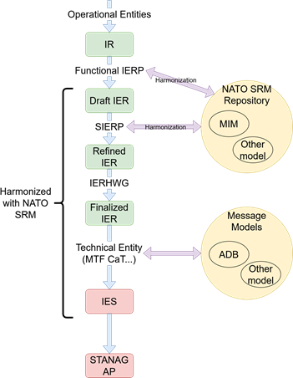

Appendix 2 – Adapted IER / IES Development Process

# Introduction

1. The fundamental change to the IER specification process is the involvement of the NATO SRM: Either re-use already defined SRM information elements or otherwise develop new SRM information elements while considering quality assurance and NATO terminology. Ultimately, the NATO SRM will contain a complete architecture in which all information elements and their semantic references available to all actors involved in the process.
2. The following describes the NATO IER Specification Process as defined in APP-15 Edition A Version 3 along with the required changes.

# Adapted NATO IER SPECIFICATION PROCESS

## IR Development (Step 1) Process Initiation – APP-15 Section 2.1.4.

* Identify the requirement to produce or consume information, the IR, either by an operational user (bottom-up) or derived from conceptual documents like operational doctrine or operating procedures (top-down).
* Engage directly with NATO SRM experts to describe doctrinal or operational requirements and information in terms of NATO SRM information elements.
* Change. Rephrase 4. to “The Functional IER Panel will ensure **direct engagement with NATO SRM experts to describe doctrinal or operational requirements** and publication of the IR into the IER Repository.”

## Draft IER Development (Step 2) – APP-15 Section 2.1.5.

* Confirm that the IR is not satisfied by an existing IER.
* Produce the Draft IER and supplement the necessary information of the IR with the support of the IR originator as required.
* Align the Draft IER with concepts, information elements, and terminology from the SRM. Extend the SRM as required.
* Change. Rephrase 2.b.(1) to “supplementing the necessary information of the IR (**with NATO SRM experts** and support of the IR originator as required).”
* Change. Rephrase 3. to “When refining the IEs and drafting the DEs, support can be provided by the NHQC3 Staff and **NATO SRM experts** to the functional IER Panel, in order to enable reuse of existing elements (*Paragraph 2.1.10 – Data Harmonization refers*).”

## Refined IER Development (Step 3) – APP-15 Section 2.1.6.

* Validate that the IER meets the operational requirement and is compliant with the current Operational Doctrine.
* Refine the Draft IER including all required elements, with the required level of detail (IER, IEs, DEs), ensuring appropriate reuse of already designed IEs and DEs and identifying and triggering harmonization tasks as required.
* Harmonize the Refined IER with concepts, information elements, and terminology from the SRM. Extend the SRM as required.
* Ensure publication of the Refined IER into the IER Repository for further processing by the IERHWG and prepare recommendations for joint prioritization purposes.
* Change. Rephrase 1.a. to “Validate the IER meets the operational requirement form the single service perspective **and NATO SRM adaptation**. For IERs developed outside the MC the validation will be performed by the SJIERP by checking across all domains.”
* Change. Rephrase 2. to “When refining the IEs and DEs, support can be provided by the NHQC3Staff **and NATO SRM experts** to the Senior IER Panel in order to enable reuse of existing IEs and DEs and identify potential harmonization tasks. (Paragraph 2.1.10 Data Harmonization refers).”

## Finalised IER Joint Validation (Step 4) – APP-15 Section 2.1.7.

* Finalize the IER as a jointly validated and NATO SRM harmonized operational requirement.
* Forward the Finalised IER to the Technical Authority for technical assessment.
* Set the priority for the Finalised IERs and register the Finalised IER into the IER Repository.
* No changes expected.

## IES(s) Development (Step 5) – APP-15 Section 2.1.8.

* Develop the required Information Exchange Specification(s) (IES).
* Appropriate bodies to use their resources (and toolchains) to create the IES(s) from the IER that is already harmonized with the SRM.
* Validate, verify, and review the toolchains’ output (IES(s)) with respect to the used standards.
* Register the IES(s) in the appropriate registries/repositories.
* No changes expected.
* Note. The NATO MTF community as represented by the MTF CaT as one of the NATO IES development bodies has already committed to the adoption of the NATO SRM as outlined within the Standard Related Documents (SRD) under the cover of STANAG 5653 - NCDF Governance (Ref. F).

## Solution(s) Publication (Step 6) – Process Termination – APP-15 Section 2.1.9.

* Generate a proposal to change an existing standardization document or develop a new standardization document as appropriate.
* No changes expected.

## Data Harmonization – APP-15 Section 2.1.10.

* One of the objectives of data harmonization is to maximise the reuse of existing data.
* Change. Rephrase 1. to “One of the objectives of data harmonization is to maximise the reuse of existing data **and semantics.**“

Appendix 3 – TERMS AND DefinitionS

* **Data Harmonization**: Data harmonization is the process of comparing two or more data component definitions and identifying commonalities among them that warrant their being combined, or harmonized, into a single data component.
* **Data Mediation**: Data mediation, also referred to as data transformation, is the conversion of data from a source data format to a destination data format. It generally occurs in two steps: (1) Mapping data elements from source to destination, and documenting any required transformation; and, (2) code generation which creates the transformation program.
* **Information Element (IE):** The factual content of information described by terms referring to specific concepts with their unique characteristics and relationships, (Source: NATOTerm, The Official NATO Terminology Database).
* **Information Requirement (IR):** An operational statement that describes the need to provide or consume one or more information elements, supplemented by meta-information that comprehensively describes the operational need for, as well as when and how the information is provided or by whom it is needed, (Source: NATOTerm).
* **Information Exchange Requirement (IER):** A finalized, harmonized and detailed operational expression of an information requirement, complemented by other operational constraints, that allow appropriate technical solutions to be identified and designed, (Source: NATOTerm).
* **Information Exchange Package Documentation (IEPD):** A set of logically cohesive W3C XML Schema documents and other supporting files, that represent one or more reusable or implementable XML information models, (Defined by SRM Vision Process Workshop).
* **Information Exchange Specification (IES):** A comprehensive and detailed description of the translation of an information exchange requirement into a specific technical solution, including appropriate justifications.

Notes: As the information exchange specification links operational requirements to technical details, the impact of technical changes on operational requirements and vice versa becomes traceable (Source: NATOTerm).

* **Harmonization:** Within the context of this document: It is the data operation to compare two set(s) of data objects between NATO SRM (MIM) and a NATO data standard; e.g., ADatP-03 with the aim to match/align the description/representation in that NATO standard with the one in MIM. This operation creates a mapping between the related data objects and ensures that both descriptions are made the same by doing necessary changes.
* **Model:** A limited representation of the real world. Models have three important properties: they are reproducing (i.e., they describe something, there is a real-world matchable concept), they are limited (not all properties are reproduced), and they are pragmatic (models map to reality only for specific purposes; there is no use in modelling properties that do not contribute to the intended use).
* **Semantic Reference Model (SRM):** The SRM provides a common language (and structure) to be used during operations and exercises. It captures the meaning of the information to be exchanged between many different systems. It is used as the common language to translate between the operational world (where IERs are defined) and the more formal technical world (where the IESs are specified). It is the conceptual and high level logical model to describe concepts relevant to the operational world (Source: SRM Concept Paper, NCDF).
* 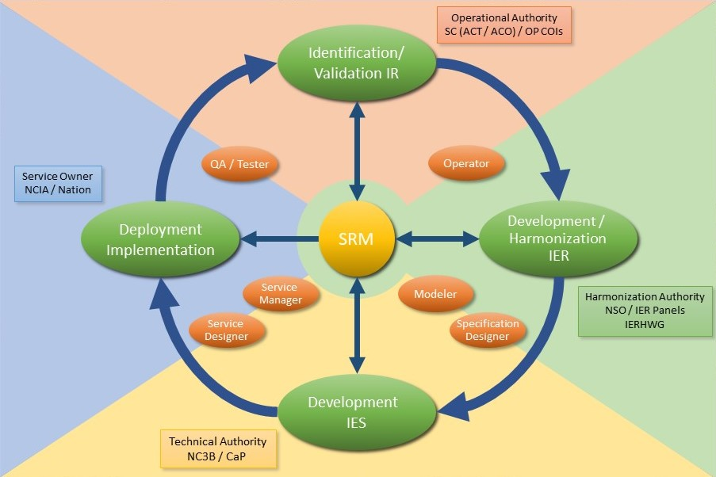**SRM Vision Process Cycle:** It is a 4 phase process cycle to specify the use the SRM at NATO. The four phases form a cycle which connects the end of Phase 4 to Phase 1 where the operator controls/compares the implementation to systems in use with the doctrine and/or operational requirement stated at the beginning of the cycle and decides if the cycle needs to be restarted or not, (Defined by SRM Vision Process Workshop).

Appendix 4 – List of abbreviations

ACO: Allied Command Operation

ACT: Allied Command Transformation

ADatP-03: Allied Data Publication Number 3 (MTF Specification)

CaP: Capability Panel

C3B: NATO Consultation, Command and Control Board

ICT: Information and Communication Technology

IE: Information Element

IR: Information Requirement

IER: Information Exchange Requirement

IERHWG: IER Harmonisation Working Group

IES: Information Exchange Specification

MC: Military Committee

MIP: Multilateral Interoperability Programme

MTF: Message Text Format

MTF CaT: MTF Capability Team

NCDF: NATO Core Data Framework

NCIA: NATO Communications and Information Agency

NSO: NATO Standardization Office

NVG: NATO Vector Graphics

SRM: Semantic Reference Model

UML: Unified Modeling Language

QAM: Quality Assurance Manager

1. Doctrinal, Organizational, Training, Material, Leadership, Personnel, Facility, Interoperability